Carlos Alberto Haro López

**Data & Analytics Solutions Engineer and Sales Rep**

haro_ca@outlook.com | +52 5549855334

8+ years of experience designing and implementing end-to-end data solutions across AWS, Azure, and GCP. **Adept at bridging technical execution and business strategy to drive innovative and scalable data solutions, for sales and for execution.  
Highlights**

Currently working as a **Product Manager and Sales Representative**, overseeing the design and execution of data projects.

**Diverse background as an individual contributor**, spanning Data Engineering (2 years), Data Science (2 years), ML Engineering (1 year), and Software Engineering (1 year)—providing a comprehensive perspective across the data lifecycle.

**Current role –** Accenture: Data & AI Manager

**Recent Experience**

2024 - present

**Accenture Data & AI Manager**

**Client:** International Bank Company

***Project:*** *Cloud MLOps framework implementation***Problem: Data science area capable of model development and deployment but facing slow iteration speed due to inexistent CI/CD (MLOps) pipelines.**

**Product**: PaaS cloud MLOps configuration and deployment (e.g. Snowflake ML, VertexAI, Sagemaker, AzureML, Databricks). Additionally, migration, deployment, and monitoring of selected models to the new platform (from legacy vendor code to open source alternatives).

**Role: Product manager, Solution Architect, Lead Engineer**

**Highlights:** Legacy model development uses proprietary autoML modelling software, migrations are made custom, matching model results and architecture.

**Outcome**: V1.0 production deployment delivered. Further improvements being worked on.

2023

**Accenture Data & AI Manager**

**Client**: International Insurance Company

***Project:*** *End-to-end analytics*

*platform assessment*

**Problem: Current efforts on data platform modernization to cloud were giving low business results.** Data warehouse/lake migrations presented high SLAs for incorporating new data (both for business and data science areas) due to bad relational modelling practices and inexistent modern analytics engineering framework.

**Product:** Prioritized roadmap for platform optimization based on technical assessment, covering the full data value chain, including OnPrem transactional DBs, OnPrem Data Warehouse, ongoing cloud migration, and all downstream BI consumption.

**Role: Lead engineer**

**Highlights:** Highly complex architecture due to hybrid data pipelines interactions.

**Outcome:** Delivered. Currently in plans for implementation.

2022

**Accenture Data & AI Consultant**

**Client**: International Retailer

***Project:*** *Omnichannel unified data model* **Problem: Omnichannel KPIs didn’t have a centralized consumption tool. Both brick & mortar and electronic sales were consulted through different methodologies and software, joined through ad hoc procedures giving different results per area.**

**Product:** Unified data model on the central cloud data warehouse, exposed via BI dashboard.

**Role: Lead engineer and solution architect**

**Highlights:** Most data available on downstream storage (cloud data warehouse) didn’t have enough granularity to reconcile a single data model. ETLs were designed and implemented from scratch in pyspark.

**Outcome: Delivered**. ETL pipelines and unified relational model still in use, dashboard faced UX/UI changes, underlying KPI semantic layer was kept intact.

***Prior roles: Software Eng (2020-2021: Mexican Development Bank), Data Scientist (2018-2020: Central Tax Administration Office), Data Eng (2017: Boutique consulting agency)***

**Software experience**

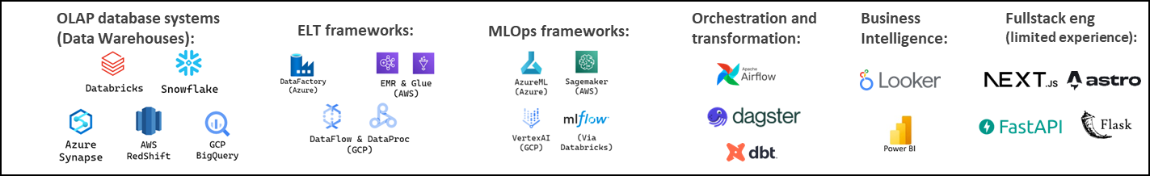

**Education –** *B.Sc Economics* (2014-2018: ITAM Instituto Tecnológico Autónomo de México). Mexico City